# **Name: Abdurrahman Qureshi**

# **Roll No: 210451**

ASSIGNEMENT 7

**1) Demonstrating Vector using command line arguments**

**CODE:**

import java.util.*;

import java.lang.*;

class EXP14VectorCMDLine{

public static void main(String[] args){

Vector<String> V = new Vector<String>();

for(int i = 0 ; i < args.length ; i++){

V.add(args[i]);

}

System.out.println("\nThe Vector contains the following:\n");

System.out.println(V);

System.out.println("\nSize of Vector = " + V.size());

System.out.println("\nCapacity of Vector = " + V.capacity());

}}

**OUTPUT:**

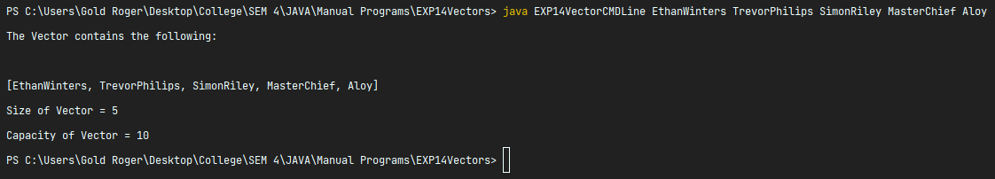

**2) WAP in Java to implement a vector that creates and stores 5 integer objects, 3 string object, 2 character objects, 2 float objects such that to accomplish the following:**

* **Add object at end of vector**
* **Remove 2nd object from vector**
* **Search for a particular object in a vector**
* **Display first & last elements in vector**
* **Display list of objects in a vector**

**CODE:**

import java.util.*;

import java.lang.*;

class EXP14VectorActivity{

public static void main(String[] args) {

Vector V = new Vector();

//Integers

int x = 1;

V.addElement(x);

for(int i = 2 ; i <= 4 ; i ++){

V.addElement(i); }

V.addElement(new Integer(5));

//Strings

V.addElement(new String("Walter White"));

V.addElement(new String("Jesse Pinkman"));

V.addElement("Gustavo Fring");

//Characters

V.addElement('$');

V.addElement('@');

V.addElement('#');

//Float

V.addElement(new Float(3.14));

V.addElement(new Float(420.69));

V.addElement(20.22);

System.out.println("Original Vector");

System.out.println(V);

System.out.println("Size of Vector = " + V.size());

System.out.println("Capacity of Vector = " + V.capacity());

V.addElement(new String("Hank Schrader"));

V.removeElementAt(1);

if(V.contains(new String("Gustavo Fring")))

System.out.println("String \'Gustavo Fring\' Found");

else

System.out.println("String \'Gustavo Fring\' not found");

System.out.println("First element of Vector : "+V.elementAt(0));

System.out.println("Last element of Vector : "+V.elementAt(V.size()-1));

System.out.println("Latest Vector");

System.out.println(V); }}

**OUTPUT:**

